

MACHINE LEARNING AND PERCEPTION LAB

Adamson University Computer Engineering Department

Laboratory Exercise 3
Data Augmentation for Improving Model Generalization
Submitted by:
Group #
Category | Exceptional  4 | Acceptable  3 | Marginal  2 | Unacceptable  1 | Score
System / Pipeline Design & Implementation (30%) | Clear, well-structured machine learning pipeline or experimental design that fully meets the stated objectives, requirements, and constraints of the lab. | Adequate pipeline or experimental design with minor limitations; meets most lab requirements. | Partial or loosely structured design; some requirements addressed but key elements are missing or incorrect. | Minimal or unclear design effort; does not address the lab requirements.
Application of Tools & Techniques  (25%) | Correct selection and expert use of appropriate tools and techniques (e.g., Python, Jupyter, ML libraries, data analysis tools); methods are effectively applied and justified. | Correct tool selection with minor errors or inconsistencies in application. | Limited, inappropriate, or incorrect tool usage; techniques partially support the task. | No meaningful or incorrect use of required tools and techniques.
Implementation & Resource Utilization  (20%) | Efficient, logical, and well-organized implementation; methods and resources are fully aligned with the problem and constraints. | Functional implementation with minor inefficiencies or redundancies. | Implementation partially works but lacks efficiency, clarity, or completeness. | Poor or non-functional implementation with little consideration of constraints.
Testing, Analysis & Validation  (15%) | Comprehensive testing and analysis; results are clearly validated, interpreted, and supported by appropriate metrics, figures, or tables. | Adequate testing and analysis with mostly correct interpretation of results. | Limited testing; analysis is incomplete, weakly supported, or partially incorrect. | No testing performed or results are incorrectly analyzed or interpreted.
Documentation & Reporting  (10%) | Clear, complete, and well-structured lab report/notebook with proper figures, tables, explanations, and reflection. | Complete documentation with minor issues in clarity, organization, or detail. | Partial documentation; missing sections, unclear explanations, or poor organization. | Incomplete, poorly written, or missing documentation.
TOTAL SCORE

Group Members
STUDENT NUMBER | NAME | CONTRIBUTION | SCORE

Submitted to:
Engr. Dexter James L. Cuaresma

Date:
mm/dd/year

OBJECTIVES

- Explain why data augmentation is used in perception-based machine learning.
- Apply common augmentation techniques to image datasets (flip, rotate, crop, brightness/contrast shift, noise).
- Compare original vs augmented samples and describe how augmentation affects learning.
- Create an augmentation pipeline that is appropriate for a classification task and avoids label corruption.
- Generate and report augmentation evidence (figures and summary logs) for reproducibility.
DISCUSSION

Introduction
In perception tasks such as image classification, models often overfit when the dataset is limited or lacks diversity. A model may learn the “exact look” of training images (lighting, angle, background) rather than learning the true features of the object. Data augmentation addresses this problem by generating realistic variations of existing training samples—without collecting new data.
This lab focuses on designing a safe and meaningful augmentation pipeline. Students will apply augmentations, visualize their effects, and ensure augmentations do not distort labels. The output of this lab will be used later in training and evaluation experiments.

1) Why Data Cleaning Matters
Data augmentation is the process of generating modified versions of training data using transformations that preserve the label. For images, this can include geometric changes (flip/rotate/crop) and photometric changes (brightness/contrast/noise).

2) Why Augmentation Improves Generalization
Augmentation helps the model become robust to:
- viewpoint changes (small rotations, crops)
- left-right orientation (flips)
- lighting changes (brightness/contrast adjustments)
- sensor noise (Gaussian noise or compression artifacts)
Instead of memorizing specific pixel patterns, the model learns more stable features.

3) Augmentation Must Preserve Label Meaning
Typical preprocessing steps include:
- Resizing
Ensures all images have the same dimensions.
- Normalization
Converts pixel values into a standard range (e.g., 0–1 or standardized mean/std).
- Data Type Conversion
Converts integer pixel values to floating-point values for numerical stability.
These steps do not change the semantic meaning of the image, but make learning more effective.
MATERIALS

Hardware
- Laptop/PC with at least 8GB RAM (recommended)
Software
- Python 3.10+
- Jupyter Notebook / Google Colab
Libraries
- numpy
- pandas
- matplotlib
- scikit-learn
- torch
- torchvision
- PIL (Pillow)

Dataset / Data Source
- CIFAR-10 (same dataset from Lab 1 & Lab 2)
- Cleaned dataset indices (optional, if you saved them in Lab 2)
PROCEDURES
Part A) Project Preparation
- Open the folder created in Lab 1:
ml-perception-labs/lab03_data_augmentation/
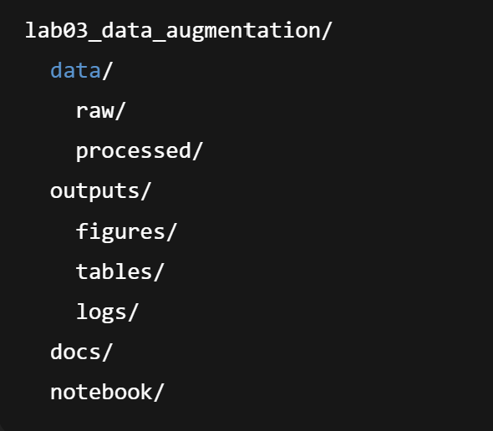
- Create the following structure if not already present:

- Create a notebook named:

notebook/Lab03_DataAugmentation.ipynb

- In the first notebook cell, display:
- Name
- Section
- Date
- Dataset name

Part B) Load Raw Dataset
- Load CIFAR-10 from data/raw/ (or download automatically if missing).
- Print:
- number of samples
- class names
- image size and type
- Display 10 original images (no augmentation) with labels.

Part C) Define Augmentation Pipeline
Required Augmentations
- Random horizontal flip
- Random rotation (small angle only, e.g., ±15 degrees)
- Random crop with padding (keeps object mostly visible)
- Color jitter (brightness/contrast slight changes)
Optional (choose at least one)
- Random grayscale (low probability)
- Gaussian noise (small)
- Random blur (small)
Important Rule:
Augmentations must preserve label meaning. Avoid extreme transformations.

Part D) Visualize Augmentations
Pick 5 fixed images (same indices each run using a random seed).
For each image:
- show the original
- show at least 4 different augmented versions
Save the visualization as:
outputs/figures/lab03_augmentation_examples.png

Part E) Augmentation Summary Logging
Write a short log describing your chosen augmentations and parameter values.
Save as:
outputs/logs/lab03_augmentation_config.txt
Minimum required log contents:
- List of augmentations used
- Rotation angle range
- Crop size and padding
- Flip probability
- Color jitter parameters
- Any optional augmentations and probability

Part F) Dataset Balance Check (Before & After)
This lab does not change labels, but you must confirm that augmentation does not change class distribution.
- Compute class distribution of the original dataset (counts).
- Explain why augmentation does not change distribution counts.
- Save class distribution table as:
outputs/tables/lab03_class_distribution.csv
RESULTS AND DISCUSSION

A. Augmentation Pipeline Design
- List each augmentation used
- Explain in 1–2 sentences how each helps generalization
B. Visual Evidence
- Insert your saved augmentation figure
- Explain what changed (rotation, crop, lighting, etc.)
C. Appropriateness of Augmentation
- Identify at least 2 augmentations that are safe for CIFAR-10
- Identify 1 augmentation that could be unsafe if used too strongly and explain why
D. Expected Effect on Training
- Discuss how augmentation can reduce overfitting
- Mention what you expect to happen to training accuracy vs validation accuracy when augmentation is used

Questions (Answer Individually)
Answer in the notebook in your own words:
- What is data augmentation and why is it commonly used in perception tasks?
- Give three examples of augmentations that are usually label-preserving for object classification.
- What is one example of an augmentation that can break labels for some tasks? Explain.
- Why is on-the-fly augmentation preferred over saving all augmented images in many projects?
- If your model overfits heavily, how can augmentation help? Give a practical explanation.

CONCLUSION

Write a conclusion including:
- Your final augmentation pipeline
- Evidence that augmentation produces realistic variations
- Why augmentation is important before training CNNs

